ILLINOIS POLLUTION CONTROL BOARD
July 26, 2018
IN THE MATTER OF:  WASTEWATER PRETREATMENT UPDATE, USEPA AMENDMENTS (January 1, 2018 through June 30, 2018) | )  )  )  )  ) | R19-5  (Identical-in-Substance Rulemaking - Water)
Proposed rule. Dismissal order.
ORDER OF THE BOARD (by C.M. Santos):
Sections 7.2 and 13.3 of the Environmental Protection Act (Act) (415 ILCS 5/7.2 and 13.3 (2012)) require the Board to adopt regulations that are “identical in substance” to regulations of the United States Environmental Protection Agency (USEPA). 415 ILCS 5/7.2 (2012). Specifically, Section 13.3 relates to wastewater pretreatment regulations that the USEPA adopted to implement Sections 307(b), (c), and (d) and 402(b)(8) and (b)(9) of the federal Water Pollution Control Act (FWPCA) (33 U.S.C. §§ 1317(b), (c), and (d) and 1342(b)(8) and (b)(9) (2011)). USEPA has codified the federal wastewater pretreatment rules as 40 C.F.R. 400 through 499.
The Board reserved this docket for any wastewater pretreatment rules amendments adopted by USEPA from January 1, 2018 through June 30, 2018. During that time, USEPA acted once, on February 6, 2018, delaying the effective date of June 29, 2015 amendments to the definition of “waters of the United States” in 40 C.F.R. § 401.11(l), which determines applicability of FWPCA provisions. The Illinois wastewater pretreatment rules do not reference or directly rely on this USEPA definition. No further action is necessary, and the Board dismisses this docket.
IT IS SO ORDERED.
I, Don A. Brown, Clerk of the Illinois Pollution Control Board, certify that the Board adopted the above order on July 26, 2018, by a vote of 5-0.

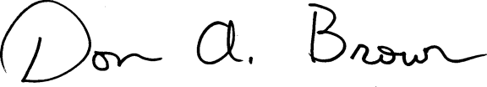
Don A. Brown, Clerk
Illinois Pollution Control Board

